Name: ___________________________________________________

**Big Money**

Imagine you had a hundred dollars, but you couldn't keep it. You had to give it away to a person or charity. To whom would you give it? What would you want them to do with it?



_________________________________________________________________________

_________________________________________________________________________

_________________________________________________________________________

_________________________________________________________________________

_________________________________________________________________________

_________________________________________________________________________

_________________________________________________________________________

_________________________________________________________________________

_________________________________________________________________________

_________________________________________________________________________

_______________

Read the short story. Then answer each question.

**Giving**

Shari was so excited for her birthday. She thought about the fun party she was going to have and the presents she would get. But, her mom told her that she had to make room for new toys by choosing some old toys to give away.

Shari was not happy. She loved all of her toys! Her mom sat down with her in front of her toy chest. They looked through the toys one at a time. Most of the toys Shari wanted to keep. Her mom put them in the “keep” pile. When they got about halfway through the toy box, Shari saw one stuffed animal that she had forgotten about.

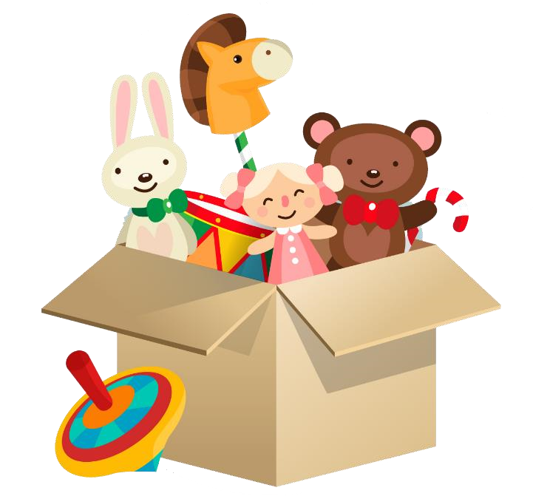“Oh, look at how cute he is! Keep him, please,” she told her mom.

“Shari, you forgot about him. Are you sure you will really play with him again? What if you get a new stuffed animal that you like better?” Mom asked.

“Well, now I remember him. I will play with him.” “That’s fine, but there might be someone else out there who would love to have him. Some kids don’t have any stuffed animals,” said Mom. Shari said she would decide later.

When they were finished, there was a very large “keep” pile, and some toys in the “donate” and “maybe” piles. Mom and Shari cleaned the “maybe” and “donate” toys, then put them in bags. They went to a place where kids lived who didn’t have homes, and asked the workers if they could hand out toys. Seeing the kids’ smiles made Shari so happy, and a lot of kids said this was the only toy they had. Shari turned to her mom and asked if they could get the “maybe” bag out of the car. The other kids needed those toys more than she did! Shari felt so great that her choice made the other kids so happy.

**Questions:**

1. Who are the characters in the story?

_______________________________________________________ _______________________________________________________ 2. What happens in the middle of the story?

_______________________________________________________ _______________________________________________________ 3. What changes about Shari during the story?

_______________________________________________________

_______________________________________________________ 4. Where did Shari and her mom go at the end of the story?

**Counting money - pennies, nickels, dimes & quarter**

Grade 2 Counting Money Worksheet

Add the coins.

1.

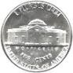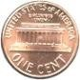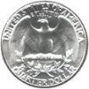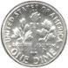

=

|  |  |
| --- | --- |
| 2.  3.  4.  5.  6.  7. | =  =  =  =  =  = |

Name:

**Urban Community Diorama**

**Directions:**

**Step 1:**

Color the backdrop and base for the diorama. Write your name on the back.

**Step 2:**

Color the cut outs. Be sure to give the community a name

by writing it on the welcome sign.

**Step 3:**

Carefully fold the backdrop and base along the

**dotted line**

.

**Step 4:**

Carefully cut out the pieces along the

**dotted lines**

.

**Step 5:**

Fold the tabs on the tree, the bus, the buildings, and the hydrant

**backward**

.

**Step 6:**

Glue the tabs on each piece to the base of the diorama:

• Glue the bus to the street.

• Glue the welcome sign to the back of the backdrop making

sure it can be seen and read.

• Glue all other cut outs between the street and backdrop.

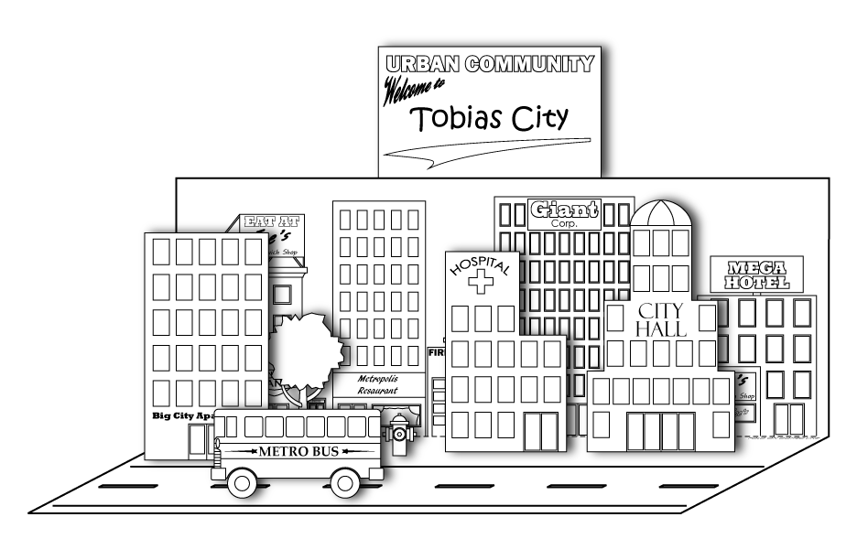

**\*Note to teachers:**

For best results, reproduce the graphics pages on card stock.

Super Teacher Worksheets - www.superteacherworksheets.com

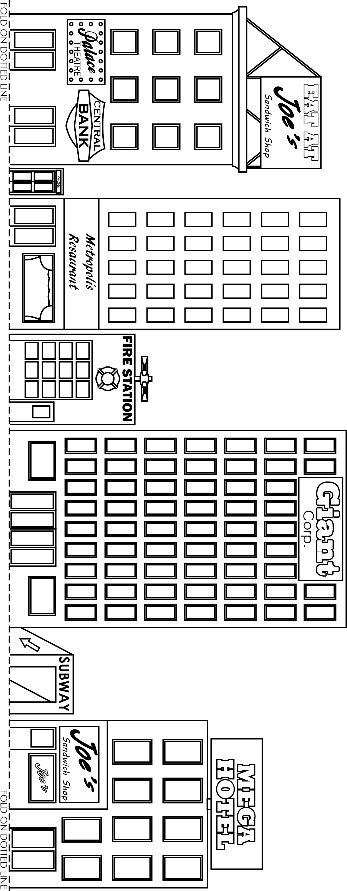

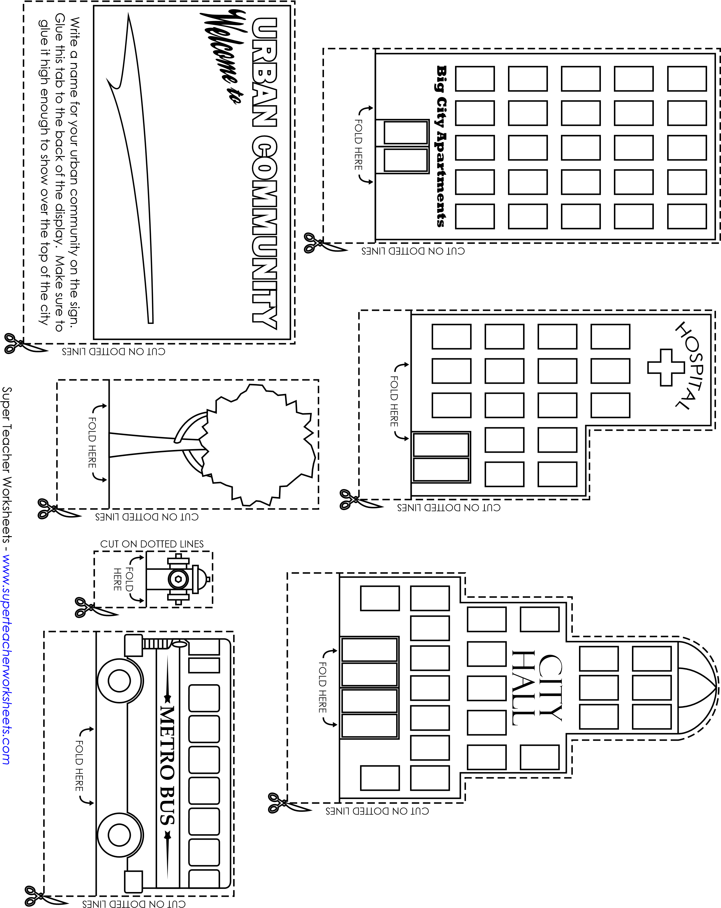

**Identifying verbs**

Grade 2 Verbs Worksheet

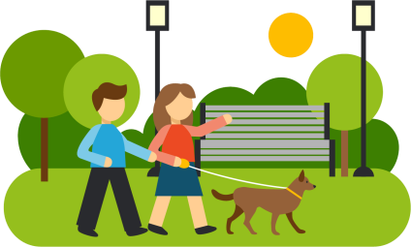

Circle the verbs in the sentence.

1.

We walked to the park together.

2.

Mike likes to read books.

3.

Jordan plays soccer with her friends.

Hint:

Verbs are ‘doing’

words.

1. 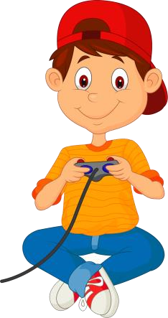The mom rocks her baby in her arms.
2. Dad parks the car in the driveway.
3. Mr. Jones distributes the sheets.
4. The children participate in the game.
5. James plays his videogame.

Write a sentence and circle the verbs.



Reading & Math for K-5 ©

**Using verbs**

Grade 2 Verbs Worksheet Circle the verbs.

|  |  |  |  |  |
| --- | --- | --- | --- | --- |
| raced | house | look | opened | sent |
| grew | plants | carried | coat | painted |
| blew | started | sat | lamp | turned |

Complete the sentences using the verbs from above.

1. My mom _____________ the room yellow.
2. They ____________ tired after all their hard work.
3. My sister and I _____________some carrots.
4. Patty ______________ me a package.
5. We ______________ the door for our guests.
6. Bob _______________ out the candles on his cake.
7. I _____________ my brother to get the best seat.
8. Dad _______________ right at the corner.
9. Susie _______________ on the park bench.
10. I _____________ the books into the library.

**Parts of Speech: Nouns**

Grade 2 Nouns Worksheet

Nouns are a person, a place or a thing.

**Circle the nouns in each sentence.**

Dad parked the car in the garage.

The dog is digging a hole in the garden.

My brother broke a glass. 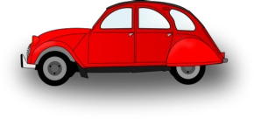

The twins like to wear pink bows in their hair.

Mom baked a cake for my birthday.

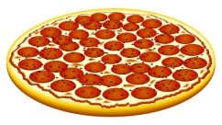Flowers grow in the garden.

I like extra cheese on my pizza.

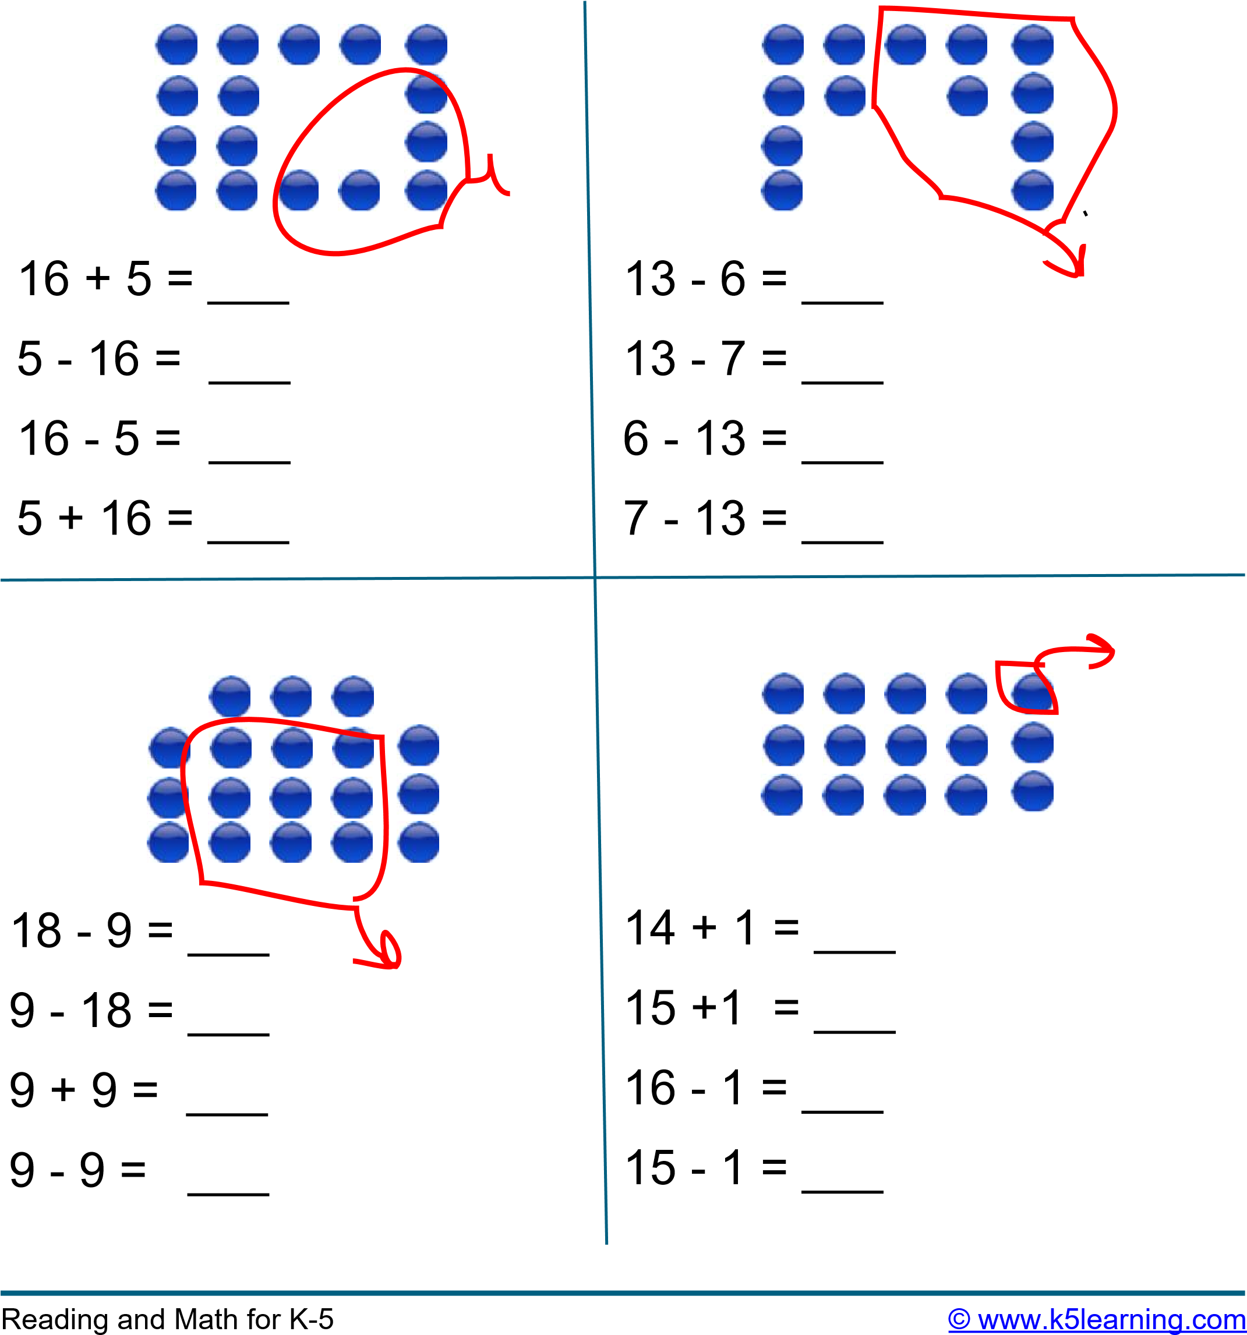

Name: ______________________________

|  |
| --- |
| Quills and Thrills  **by Kelly Hashway**  Forests are homes to many animals. But there’s one forest creature that gives off an odor and makes a rattling sound when it feels threatened. No, it’s not a cross between a skunk and a rattlesnake. It’s a porcupine.  Porcupines are covered with quills— about 30,000 on average. The quills cover most of the porcupine’s body with the exception of the face, stomach, and the inside of the animal’s legs. You probably know that rattlesnakes shake their tails to scare off predators. It’s like a warning signal. Well, porcupines do something similar. When a porcupine is approached  by a predator or is feeling threatened, it rustles its quills. This creates a rattling sound as a warning sign, telling other animals or even humans to back off. But the sound isn’t the only warning. When a porcupine raises its quills like this, it produces an odor. So the animal uses  both sound and smell to ward off enemies.  If a porcupine is attacked, its quills act as protection. You may have heard rumors that porcupines can shoot their quills at attackers. This isn’t true. What actually happens is when a porcupine tenses the muscles around their quills and makes them stand up, the quills become loose. If an animal gets too close to the porcupine and brushes up against it, the quills will  detach and stick into the attacker.  **Super Teacher Worksheets -** [**www.superteacherworksheets.com**](http://www.superteacherworksheets.com/) |

**Super Teacher Worksheets -** [**www.superteacherworksheets.com**](http://www.superteacherworksheets.com/)

|  |
| --- |
| Quills and Thrills  **by Kelly Hashway**   1. Which parts of a porcupine's body are not covered with quills?   ___________________________________________________________________________________________  ___________________________________________________________________________________________   1. When a porcupine is feeling threatened by a predator, what does it do?    1. shoots quills at the predator    2. makes a rattling sounds with its quills    3. curls up in a ball    4. thumps its tail on the ground 2. A porcupine's quills are barbed. What does this mean?    1. They are poisonous to people and animals.    2. They are coated with antibiotic fatty acids.    3. They grow back when the porcupine loses them.    4. They get stuck in an enemy's skin. 3. What is the author's purpose for writing this article.    1. to explain how porcupines eat, live, and play    2. to teach readers how porcupines defend themselves    3. to describe the life cycle of a porcupine    4. to entertain readers with a story about porcupines 4. According to the information in the article, Which fact about porcupines in not true?    1. When a porcupine's quills stand up, they become loose.    2. When a porcupine raises its quills, it produces an odor.    3. Porcupines have about thirty thousand quills.    4. It takes several years for a porcupine to regrow lost quills.   **Super Teacher Worksheets -** [**www.superteacherworksheets.com**](http://www.superteacherworksheets.com/) |