Weekly Preschool Lesson Ideas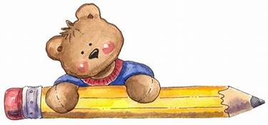

Week of: May 18th- 22nd

|  |  |  |  |  |  |
| --- | --- | --- | --- | --- | --- |
|  | Monday | Tuesday | Wednesday | Thursday | Friday |
| Alphabet  Look at a book or magazine and… | Find 10 I’s and J’s  (upper or lower case) | Find 10 K’s and L’s  (upper or lower case) | Find 10 M’s and N’s  (upper or lower case) | Find 10 O’s and P’s  (upper or lower case) | Find 10 Q’s and R’s  (upper or lower case) |
| Writing | Dip a Q-tip or paint brush in water and make letters on wax paper | Write or trace name on paper with a pencil | Build letters with anything you can think of, use your imagination | Write or trace name on paper with a pencil | Take a Break from Writing |
| Math | Take turns creating and extending patterns | Take a Nature walk with a grown-up and count the flowers you see. | Sort something by size – smallest to biggest | Look for numbers in print (newspaper, magazine, signs) | Find shapes in your environment. (ex. Hoola hoop, circle/ stop sign, octagon) |
| Pre-K Facebook page |  | Watch story on McKeesport Area Pre-K Counts Facebook Page |  | Watch story on McKeesport Area Pre-K Counts Facebook Page |  |
| Motor | Fine: Practice cutting a zig zag line | Gross: hop on one foot five times (practice with both feet) | Fine: Use a crayon/ marker to trace a lzig-zag line | Gross: march around the room while singing the Ants Go Marching | Fine: Use tweezers or clothespins to pick up and move small items. |
| Oral language | Create or sing a song together. | Play 'I Spy' using words that describe an objects position. (ex. Next to the Table) | Say a word and have your child provide a rhyming word | Play Simon Says using directional words | Expand vocabulary by introducing a new word today! |
| Independence/ Social Emotional Development | Make sure to practice saying please and thank you when asking for something. | Practice remembering your phone number. | Pick out your own clothes and dress yourself ! | Practice remembering your address. Start with the name of your city or street. | Do something kind for someone today ! |

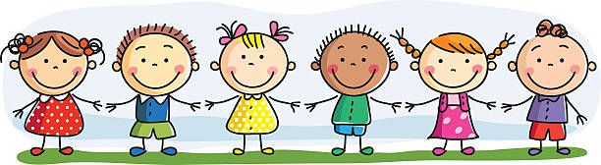

Name: _______________________ Teacher: _________________________ Parent Signature: _______________________

Weekly Preschool Lesson Ideas

Week of: May 25th-May 29th

|  |  |  |  |  |  |
| --- | --- | --- | --- | --- | --- |
|  | Monday | Tuesday | Wednesday | Thursday | Friday |
| Alphabet  Look at a book or magazine and… | Look for the letters:  U, S, and A | Find 10 S’s and T’s  (upper or lower case) | Find 10 U’s and V’s  (upper or lower case) | Find 10 W’s and X’s  (upper or lower case) | Find 10 Y’s and Z’s  (upper or lower case) |
| Writing | Write and decorate the letters USA | Write or trace name on paper with a pencil | Build letters with crayons | Write or trace name on paper with a pencil | Take a Break from Writing |
| Math | Tally the number of U’s, S’s, and A’s you see today | Create shapes using outdoor items (sticks, leaves, stones) | Count toys or items as you clean them up | Sort toys or items by color | Go on a shape scavenger hunt and find as many (ex. Circles) as you can in your home |
| Pre-K Facebook page |  | Watch story on McKeesport Area Pre-K Counts Facebook Page |  | Watch story on McKeesport Area Pre-K Counts Facebook Page |  |
| Motor | Fine: Cut out a parade banner | Gross: March with your parade banner | Fine: Zip your jacket three times. | Gross: Hop, skip, and jump across the room or in the yard. | Fine: String beads onto a string or pipe cleaner. |
| Oral language | Fill a bucket or pan with nature and play with it (grass, leaves, sticks, pine cones) | Talk to your child on a pretend or real phone. Have at least three exchanges on a topic. | Put an item in a bag. Have your child reach in without looking and describe it ! | Say a word and have your child provide a rhyming word | Expand vocabulary by introducing a new word today! |
| Independence/ Social Emotional Development | Thank a person who served in the military | Help make your bed or fold laundry | Clean up after playing with toys | Draw faces on paper. Have your child identify the emotion (angry, happy, sad) | Watching a show, a movie or reading a book. Talk about how the characters are feeling and how you can tell |



Name: _______________________ Teacher: _________________________ Parent Signature: _______________________